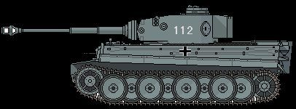
Figure 1Panzer leher
+1
17th SS PG

